**Using equation editor**

You might need initialise it first <https://www.youtube.com/watch?v=Ee2g0l6I2zk>

Once it’s there you can then insert an equation <https://www.youtube.com/watch?v=4vF4HB1QfHs&t=186s>

Insert tab then at the end there is an for insert equation pi sign($π$) and an omega sign for insert symbol (Ω).

Tip with insert symbol if you can’t find the one you want then use a search engine for with the name of the symbol and character Unicode and you can put this number in the more symbols part.

Choose the insert equation you can pick one of the standard formats or just enter your own.

You now have an equation to edit (image only shown below).



If you click out of it and in again your options will have disappeared – go to option tab equation tools above your normal tabs and they will reappear.

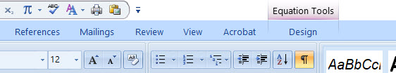

Here are a few of the standard ones you can get to if you use the pull down arrow at the bottom of the insert equation tab:

$$A=πr^{2}$$

$${\left(x+a\right)}^{n}=\sum_{k=0}^{n}{\left({n \atop k}\right)x^{k}a^{n-k}}$$

$${\left(1+x\right)}^{n}=1+\frac{nx}{1!}+\frac{n\left(n-1\right)x^{2}}{2!}+…$$

$$x=\frac{-b±\sqrt{b^{2}-4ac}}{2a}$$

$$e^{x}=1+\frac{x}{1!}+\frac{x^{2}}{2!}+\frac{x^{3}}{3!}+…, -∞<x<∞$$

Once you have inserted the equation you need to think ahead as it uses templates that you then add the data to.

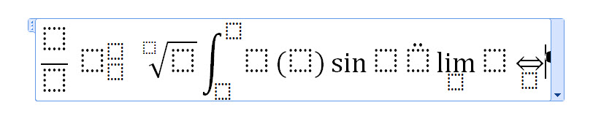editable version:

$$\frac{}{} {}_{}^{} \sqrt{}\int{}\left(\right)\sin{}\ddot{}\lim_{}{}\overset{⇔}{}$$

Once you have the template you can click in the boxes and type what you need.

Use the arrow keys if you’re struggling to get to the right component with your mouse.